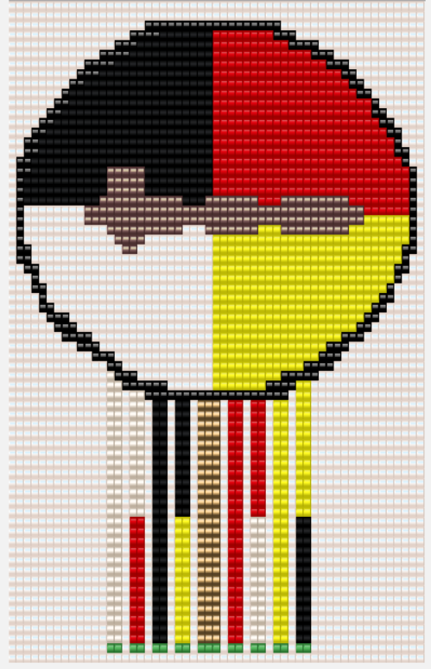
Wahissa Lodge #118
IA Recognition Program

The phrase “It Takes a Family to Dress a Dancer” means that it requires more than one individual to do the job at hand, whether it be Dancing, Drumming, or Ceremonies, they all have people working to ensure everything is in order. This program is designed to instill the traditions of Wahissa Lodge #118 by rewarding leadership and excellence in the field of IA. Youth & Adult arrowmen will be rewarded based on the amount of hard work they have and will continue to produce for not only themselves but others in our lodge, section, and organization. To show different levels of achievement we will use a system of bead dangles suspended from a beaded rosette necklace, not so unlike the segments and IA patches of other lodges. This design is something that can be worn with the uniform, regalia, or anything you like. There are 4 fields in which to earn recognition, Dance, Drum, Ceremonies, and Leadership. It is not possible to receive multiple of the same level dangle.
Honor Chapter Requirement: have at least one member of your chapter receive Gold Level status each year
Requirements:
Youth
Dance
White Level:
- Compete as an individual dancer at Conclave or NOAC
- Participate as a dancer in a Wednesday Night Ceremony
White/Red Level:
- Place at Conclave or make Top 10 at NOAC
- Participate as a Pipe Dancer in a Wednesday Night Ceremony

Ceremonies
Black Level:
- Be a principal of an OA Ceremony in 3 separate ceremonies (i.e. Crossover, Pre-Ordeal, Ordeal, Brotherhood or Vigil Ceremonies); whether it’s a different ceremony or a different event does not matter
- Compete at Conclave
- Serve on the Ceremony Support/Setup Team for 3 events
Black/Yellow Level:
- Place at Conclave or make Top 10 at NOAC as a character

Drum
Red Level:
- Participate as a drummer in a Wednesday Night Ceremony
- Compete on a Drum team at Conclave or NOAC
Red/White Level:
- Place at Conclave or make Top 10 at NOAC as part of a Drum team
- Participate and perform with a Drum group at 3 Lodge events or Drum practices
Leadership
Yellow Level:
- Serve as a Chapter VCIA
- Serve as a Lodge IA Chairman
Yellow/Black Level:
- Serve as a Lodge VCIA
- Serve on one of the following: DERT (Dancer Emergency Repair Team) or CSST (Ceremony Support/Setup Team)

In addition to the levels of achievement under these four areas there is also a level that applies to the arrowmen that travel and put in the extra effort to develop and maintain IA traditions in our Lodge and Section.

Youth Gold Level
- Attend 2 events, powwows, or competitions etc. at another Lodge/Section or in the Native community
- Complete all the previously stated requirements for your respective area of IA

Adult
*If you completed any of the Youth requirements/levels/categories and then became an Adult, they will then transfer and be awarded to you. This means it is not necessary to complete the Adult requirements for the same field if you provide information in an application.*

Dance
White Level:
- Participate as a dancer in a Wednesday Night Ceremony
- Help youth dancers get prepared for dances
White/Red Level:
- Help a Youth Arrowman make at least 2 items of dance regalia for their style

Ceremonies
Black Level:
- Serve on the Ceremony Support/Setup Team for 3 events
Black/Yellow Level:
- Help a Youth Arrowman make at least 2 items of ceremonies regalia for their character
- Advise a ceremonies team

Drum
Red Level:
- Participate as a drummer in a Wednesday Night Ceremony
Red/White Level:
- Mentor and advise a Drum group at three Lodge events or Drum practices
- Advise a drum team

Leadership
Yellow Level:
- Serve as a Chapter VCIA Advisor
- Serve as a Lodge IA Chairman Advisor
Yellow/Black Level:
- Serve as a Lodge VCIA Advisor
- Serve on one of the following: DERT (Dancer Emergency Repair Team) or CSST (Ceremony Support/Setup Team)

Adult Gold Level
- Shuttle IA members to/from/during events where regalia/drums need to be moved often
- Attend 2 events, powwows, or competitions etc. at another Lodge/Section or in the Native community
- Complete all the previously stated requirements for your respective area of IA
IA Recognition Award Level Application
*If applying for more than one category/level then please fill out multiple applications and submit together*

NAME:

CATEGORY:

LEVEL:

DESCRIPTION: (Date, Event)

WITNESS CONTACT: (Name, Email, Phone)

SIGNATURE:____________________ DATE:__________

